Module-4 NUnit and Moq

Mocking, Test-Driven Development, and Dependency Injec-tion
Mocking is the practice of standing in fake objects for real dependencies during a test. This section covers the underlying ideas — mocking, test doubles, and dependency injection — before applying them across three hands-on labs.

Mocking and Isolation
Isolation means a unit test only exercises the logic of the class under test, not the behavior of everything it talks to. A class that emails customers, reads the file system, or queries a database pulls in slow, unreliable, or unavailable infrastructure the moment you try to test it directly. Mocking replaces each of those dependencies with a stand-in object that the test controls completely, so a failure always points at the class under test rather than a network hiccup or a missing file.

Test Doubles: Mock vs. Fake vs. Stub
Test double is the umbrella term for any object substituted for a real dependency in a test. The common kinds differ in what they’re used for:
  - Stub — returns canned answers to whatever calls the test needs, with no real logic behind it. Used to feed the class under test with predetermined data.
  - Fake — a real, working implementation that just isn’t suitable for production, such as an in-memory list standing in for a database table.
  - Mock — programmed with expectations about which calls it should receive, and can be checked afterward to confirm those calls actually happened. A mock verifies behavior; a stub just supplies data.
Moq, despite the name, can produce all three depending on how it’s configured — Setup(...).Returns(...) behaves like a stub, while mock.Verify(...) adds the behavior-checking that makes it a true
mock.

Key Advantages of TDD
Test-Driven Development means writing the test before the code it tests, then writing just enough code to pass it. The main payoffs: it forces testable design from the very start, since code that’s hard to mock or isolate gets refactored immediately rather than retrofitted later; it keeps each unit of work small, because you can’t write a test for something you haven’t scoped out; and it leaves a regression safety net in place for every later refactor.

Dependency Injection
Dependency Injection (DI) means a class receives its dependencies from the outside rather than constructing them itself. A class that does new SqlConnection(...) internally can only ever talk to a real database; a class that accepts an IDbConnection as a parameter can be handed a mock instead. DI is what makes mocking possible in the first place — everything in this section builds on it.

Constructor Injection
The dependency is passed in through the class’s constructor and held for the lifetime of the instance. This is the most common form of DI, used in the Mail Sender lab below and again later for the Calculator-style classes covered in the NUnit labs.

Method Injection
The dependency is passed as a parameter to a single method rather than the constructor, useful when a class doesn’t need the dependency for its whole lifetime — only for one specific call. The Player Manager lab below uses this style, via an optional parameter on a static factory method.

Hands-On 1: Writing Testable Code with Moq
An application emails customers after every transaction. Testing the module that triggers those emails without actually sending mail during a test run means mocking the mail dependency rather than calling a real SMTP server.

Step 1 — Create the Class Library Project
Create a Class Library (C#) project named CustomerCommLib. Rename the default Class1 to MailSender.

Step 2 — Define the IMailSender Interface
namespace CustomerCommLib
{
public interface IMailSender
{
bool SendMail(string toAddress, string message);
}
}

Step 3 — Implement the Real Mail Sender
using System.Net; using System.Net.Mail;
namespace CustomerCommLib
{
public class MailSender : IMailSender
{
public bool SendMail(string toAddress, string message)
{
var mail = new MailMessage();
var smtpServer = new SmtpClient("smtp.gmail.com");
mail.From = new MailAddress("your_email_address@gmail.com"); mail.To.Add(toAddress);
mail.Subject = "Test Mail"; mail.Body = message;
smtpServer.Port = 587;
smtpServer.Credentials = new NetworkCredential("username", "password"); smtpServer.EnableSsl = true;
smtpServer.Send(mail);
return true;
}
}
}
This class can’t be unit tested directly — it reaches a real SMTP server the moment it runs.

Step 4 — Write the Testable CustomerComm Class
CustomerComm receives IMailSender through its constructor, so a test can supply a mock instead of the real MailSender.

namespace CustomerCommLib
{
public class CustomerComm
{
private readonly IMailSender _mailSender;
public CustomerComm(IMailSender mailSender)
{
_mailSender = mailSender;
}
public bool SendMailToCustomer()
{
return _mailSender.SendMail("cust123@abc.com", "Some Message");
}
}
}

Step 5 — Build the Project
Build CustomerCommLib and confirm it compiles before moving on to the test project.

Step 6 — Create the Test Project
Create a Class Library project named CustomerCommLib.Tests and add NUnit, NUnit3TestAdapter, Microsoft.NET.Test.Sdk, and Moq via NuGet. Add a project reference to CustomerCommLib.

Step 7 — Write the Test Methods
The mock is configured so that SendMail accepts any two strings and always returns true.
using Moq;
using NUnit.Framework; using CustomerCommLib;
namespace CustomerCommLib.Tests
{
[TestFixture]
public class CustomerCommTests
{
private Mock<IMailSender> _mockMailSender; private CustomerComm _customerComm;
[OneTimeSetUp] public void Setup()
{
_mockMailSender = new Mock<IMailSender>();
_mockMailSender
.Setup(m => m.SendMail(It.IsAny<string>(), It.IsAny<string>()))
.Returns(true);
_customerComm = new CustomerComm(_mockMailSender.Object);
}
[TestCase]
public void SendMailToCustomer_MailSenderSucceeds_ReturnsTrue()
{
bool actual = _customerComm.SendMailToCustomer();

Assert.That(actual, Is.True);
}
}
}
It.IsAny<string>() tells Moq to match the call regardless of which address or message was passed in — only the mocked IMailSender is checked, so no real email is ever sent.

Step 8 — Run the Tests
dotnet test
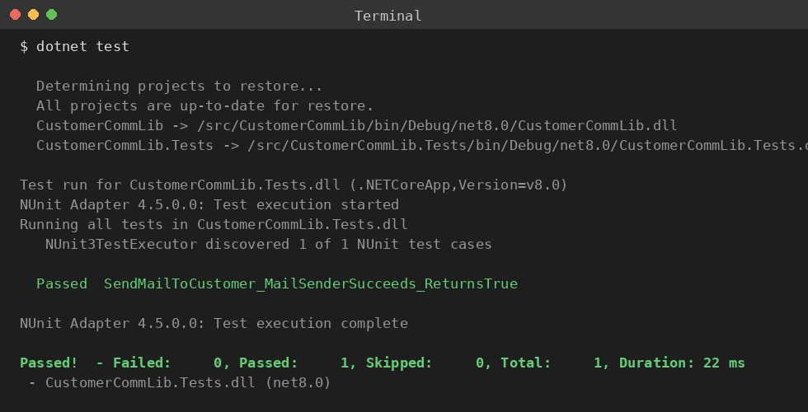
Figure 1: The mocked SendMailToCustomer test passing without contacting a real mail server.

Step 9 — Break the Test on Purpose
Change SendMailToCustomer to ignore the mail sender’s result:
public bool SendMailToCustomer()
{
_mailSender.SendMail("cust123@abc.com", "Some Message");
// Bug: ignores the mail sender’s result and always returns false. return false;
}

Step 10 — Rerun the Tests
dotnet test

Step 11 — Observe the Result
The test now fails, since the mock still returns true but SendMailToCustomer no longer reports it.
Revert the change once you’ve confirmed the test catches it.

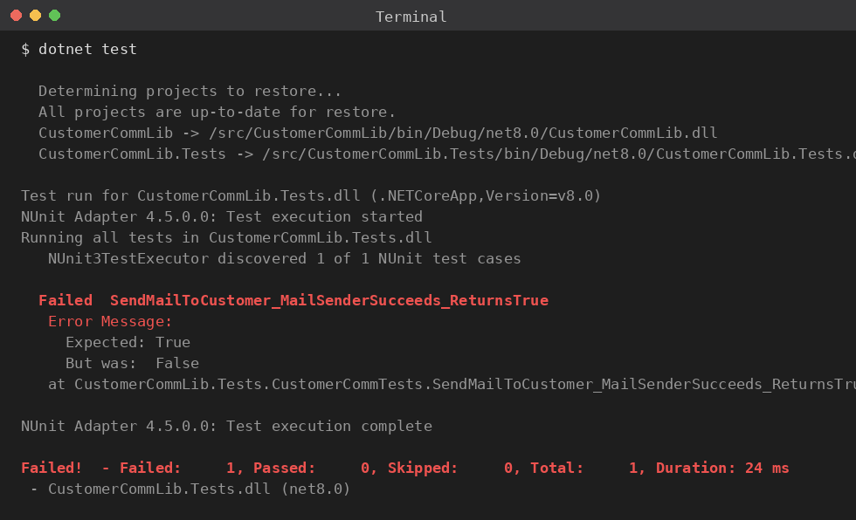
Figure 2: After hardcoding a false return, the test fails and shows the expected-versus-actual mismatch.

Hands-On 2: Mocking the File System for Unit Tests
An application searches for files under a given path using Directory.GetFiles(). Because that method is static, nothing that calls it directly can be unit tested — there’s no way to substitute a mock for a static call. The fix is to wrap it behind an interface.

Step 1 — Create the Class Library Project
Create a Class Library (C#) project named MagicFilesLib. Rename the default Class1 to DirectoryExplorer.

Step 2 — Define the IDirectoryExplorer Interface
using System.Collections.Generic;
namespace MagicFilesLib
{
public interface IDirectoryExplorer
{
ICollection<string> GetFiles(string path);
}
}

Step 3 — Implement the Real Directory Explorer
using System.Collections.Generic; using System.IO;
namespace MagicFilesLib
{
public class DirectoryExplorer : IDirectoryExplorer
{
public ICollection<string> GetFiles(string path)

{
return Directory.GetFiles(path);
}
}
}

Step 4 — Write the Testable FileSearchService Class
FileSearchService receives IDirectoryExplorer through its constructor, so tests can supply a mock instead of touching the real file system.
namespace MagicFilesLib
{
public class FileSearchService
{
private readonly IDirectoryExplorer _directoryExplorer;
public FileSearchService(IDirectoryExplorer directoryExplorer)
{
_directoryExplorer = directoryExplorer;
}
public ICollection<string> GetFilesInPath(string path)
{
return _directoryExplorer.GetFiles(path);
}
}
}
Wrapping the static call behind IDirectoryExplorer is what makes GetFilesInPath testable. DirectoryExplorer itself still touches the real file system, but anything depending on the interface — like FileSearchService — can be tested against a mock.

Step 5 — Build the Project
Build MagicFilesLib and confirm it compiles.

Step 6 — Create the Test Project
Create a Class Library project named MagicFilesLib.Tests and add NUnit, NUnit3TestAdapter, Microsoft.NET.Test.Sdk, and Moq. Add a project reference to MagicFilesLib.

Step 7 — Write the Test Methods
The mock returns two hardcoded file names regardless of the path passed in.
using System.Collections.Generic; using Moq;
using NUnit.Framework; using MagicFilesLib;
namespace MagicFilesLib.Tests
{
[TestFixture]
public class FileSearchServiceTests
{
private readonly string _file1 = "file.txt";

private readonly string _file2 = "file2.txt";
private Mock<IDirectoryExplorer> _mockDirectoryExplorer; private FileSearchService _fileSearchService;
[OneTimeSetUp] public void Setup()
{
_mockDirectoryExplorer = new Mock<IDirectoryExplorer>();
_mockDirectoryExplorer
.Setup(d => d.GetFiles(It.IsAny<string>()))
.Returns(new List<string> { _file1, _file2 });
_fileSearchService = new FileSearchService(_mockDirectoryExplorer.Object);
}
[TestCase(@"C:\Reports")]
public void GetFilesInPath_MockedDirectory_ReturnsExpectedFiles(string path)
{
var actual = _fileSearchService.GetFilesInPath(path);
Assert.That(actual, Is.Not.Null); Assert.That(actual.Count, Is.EqualTo(2)); Assert.That(actual, Does.Contain(_file1));
}
}
}
This test checks three related conditions — not null, the right count, and the right content — rather than splitting into three tests, since together they describe a single behavior: retrieving the mocked file list unchanged.

Step 8 — Run the Tests
dotnet test
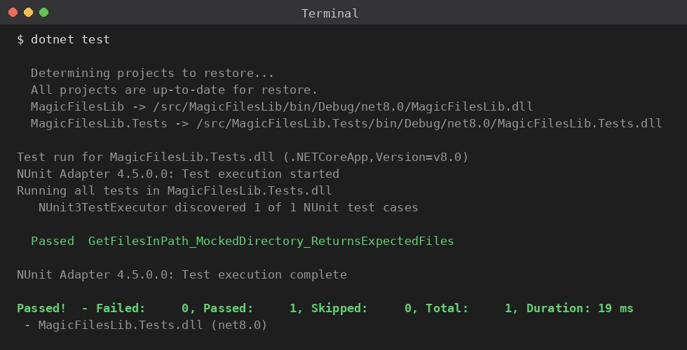
Figure 3: GetFilesInPath returning the two mocked file names without touching the real file system.

Step 9 — Break the Test on Purpose
Introduce a bug that drops a file before returning the list:
public ICollection<string> GetFilesInPath(string path)
{
// Bug: drops the last file before returning.
var files = new List<string>(_directoryExplorer.GetFiles(path)); files.RemoveAt(files.Count - 1);
return files;
}

Step 10 — Rerun the Tests
dotnet test

Step 11 — Observe the Result
The count assertion now fails — one file is missing from the result, even though the mock still returned both.
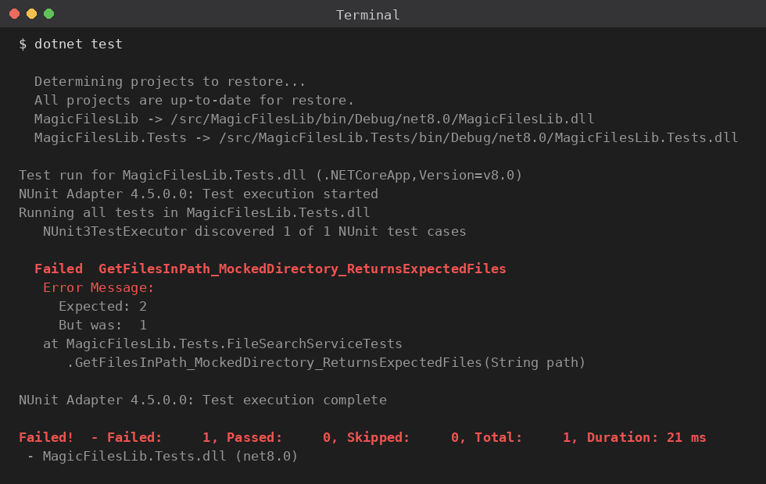
Figure 4: After the bug drops a file, the count assertion fails and reports one file instead of the expected two.

Revert the change once you’ve confirmed the test catches it.

Hands-On 3: Mocking a Database for Unit Tests
An application stores and retrieves player records in a network database. The class responsible for that, PlayerMapper, talks to SQL Server directly, so nothing that depends on it can be unit tested without also having a real database available.

Step 1 — Create the Class Library Project
Create a Class Library (C#) project named PlayersManagerLib. Rename the default Class1 to PlayerMapper.

Step 2 — Define the IPlayerMapper Interface
namespace PlayersManagerLib
{
public interface IPlayerMapper
{
bool IsPlayerNameExistsInDb(string name); void AddNewPlayerIntoDb(string name);
}
}

Step 3 — Implement the Real Player Mapper
using System.Data.SqlClient;
namespace PlayersManagerLib
{
public class PlayerMapper : IPlayerMapper
{
private readonly string _connectionString =
"Data Source=(local);Initial Catalog=GameDB;Integrated Security=True";
public bool IsPlayerNameExistsInDb(string name)
{
using (var connection = new SqlConnection(_connectionString))
{
connection.Open();
using (var command = connection.CreateCommand())
{

@name";
command.CommandText = "SELECT COUNT(*) FROM Player WHERE Name = command.Parameters.AddWithValue("@name", name);
var existingPlayersCount = (int)command.ExecuteScalar();

return existingPlayersCount > 0;
}
}
}
public void AddNewPlayerIntoDb(string name)
{
using (var connection = new SqlConnection(_connectionString))
{
connection.Open();

using (var command = connection.CreateCommand())
{
command.CommandText = "INSERT INTO Player ([Name]) VALUES (@name)
";
command.Parameters.AddWithValue("@name", name);
command.ExecuteNonQuery();
}
}
}
}
}
This class can’t be unit tested directly — both methods open a real SqlConnection.

Step 4 — Write the Player Class with Method Injection
Player.RegisterNewPlayer accepts IPlayerMapper as an optional parameter on a static fac-tory method rather than through a constructor — method injection instead of constructor injection. A test supplies a mock directly to the method; production code leaves the parameter out and gets the real PlayerMapper.
using System;
namespace PlayersManagerLib
{
public class Player
{
public string Name { get; private set; } public int Age { get; private set; }
public string Country { get; private set; } public int NoOfMatches { get; private set; }
public Player(string name, int age, string country, int noOfMatches)
{
Name = name;
Age = age;
Country = country; NoOfMatches = noOfMatches;
}
public static Player RegisterNewPlayer(string name, IPlayerMapper playerMapper
= null)
{
// If no mapper is supplied, fall back to the real one; tests supply a mock instead.
playerMapper ??= new PlayerMapper();
if (string.IsNullOrWhiteSpace(name))
{
throw new ArgumentException("Player name can’t be empty.");
}
if (playerMapper.IsPlayerNameExistsInDb(name))
{
throw new ArgumentException("Player name already exists.");
}

playerMapper.AddNewPlayerIntoDb(name);
return new Player(name, 23, "India", 30);
}
}
}

Step 5 — Build the Project
Build PlayersManagerLib and confirm it compiles.

Step 6 — Create the Test Project
Create a Class Library project named PlayersManagerLib.Tests and add NUnit, NUnit3TestAdapter, Microsoft.NET.Test.Sdk, and Moq. Add a project reference to PlayersManagerLib.

Step 7 — Write the Test Methods
The mock is set up so IsPlayerNameExistsInDb returns false, letting RegisterNewPlayer proceed as if the name were new.
using Moq;
using NUnit.Framework; using PlayersManagerLib;
namespace PlayersManagerLib.Tests
{
[TestFixture]
public class PlayerTests
{
private Mock<IPlayerMapper> _mockPlayerMapper;
[OneTimeSetUp] public void Setup()
{
_mockPlayerMapper = new Mock<IPlayerMapper>();
_mockPlayerMapper
.Setup(m => m.IsPlayerNameExistsInDb(It.IsAny<string>()))
.Returns(false);
}
[TestCase("Sachin")]
public void RegisterNewPlayer_NewPlayerName_ReturnsPlayerWithExpectedDefaults( string name)
{
var player = Player.RegisterNewPlayer(name, _mockPlayerMapper.Object);
Assert.That(player.Name, Is.EqualTo(name)); Assert.That(player.Age, Is.EqualTo(23)); Assert.That(player.Country, Is.EqualTo("India")); Assert.That(player.NoOfMatches, Is.EqualTo(30));
}
[Test]
public void RegisterNewPlayer_NameAlreadyExists_ThrowsArgumentException()
{

_mockPlayerMapper
.Setup(m => m.IsPlayerNameExistsInDb("Sachin"))
.Returns(true);

Object),
}
}
}
Assert.That(() => Player.RegisterNewPlayer("Sachin", _mockPlayerMapper.
Throws.TypeOf<ArgumentException>());

Step 8 — Run the Tests
dotnet test
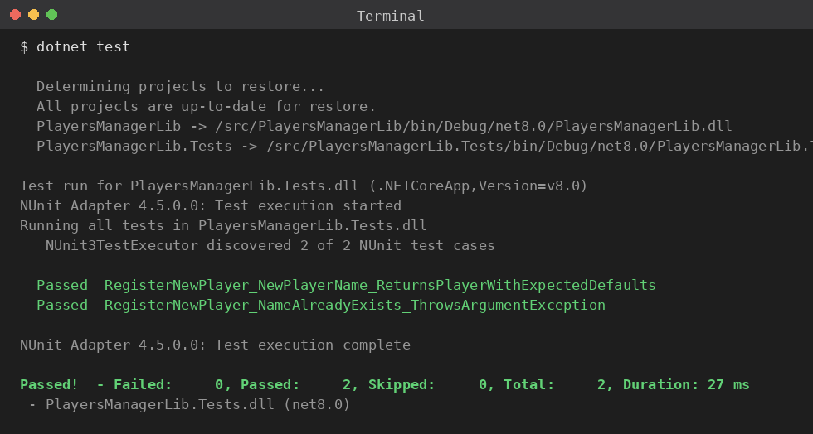
Figure 5: Both Player tests passing against a mocked IPlayerMapper, with no real database involved.

Step 9 — Break the Test on Purpose
Remove the existing-name check so a duplicate name is silently accepted:
public static Player RegisterNewPlayer(string name, IPlayerMapper playerMapper = null)
{
playerMapper ??= new PlayerMapper();
if (string.IsNullOrWhiteSpace(name))
{
throw new ArgumentException("Player name can’t be empty.");
}
// Bug: skips the existing-name check entirely. playerMapper.AddNewPlayerIntoDb(name);
return new Player(name, 23, "India", 30);
}

Step 10 — Rerun the Tests

dotnet test

Step 11 — Observe the Result
RegisterNewPlayer NameAlreadyExists ThrowsArgumentException now fails, since no ex-ception is thrown for a duplicate name, while the other test still passes.
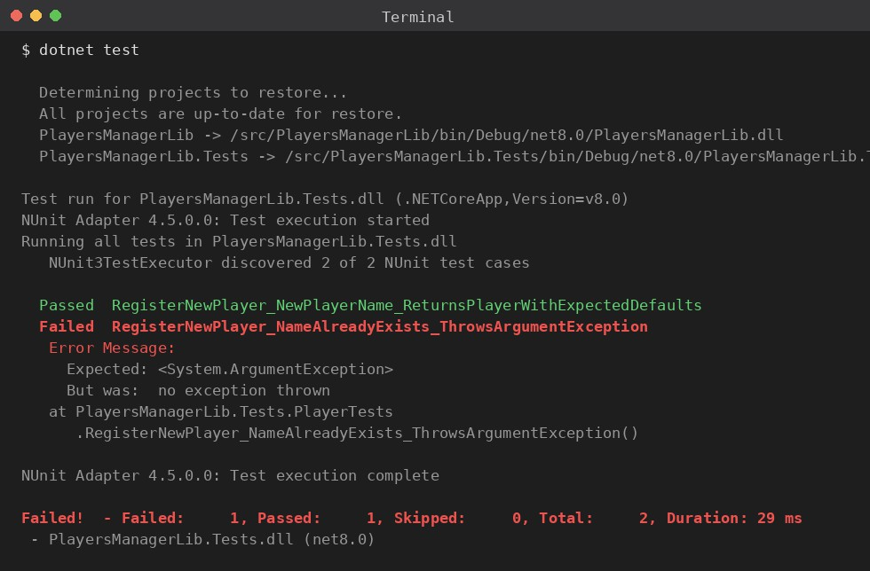
Figure 6: After removing the existing-name check, the duplicate-name test fails to see the expected exception, while the other test still passes.

Revert the change once you’ve confirmed the test suite catches it.

Why Unit Testing
Manual testing — clicking through an app and checking that things look right — catches some bugs, but it doesn’t scale well as an app grows. Unit testing addresses this gap.
A unit test is a small piece of code that checks another small piece of code: it calls a single method with known inputs and checks the output. If a bug is introduced later, the test fails and points directly at what broke.

Unit Testing vs. Functional Testing
Functional testing checks that a whole feature works end to end — logging in, adding a product to a cart, checking out. It’s typically slower and handled by QA. Unit testing is narrower and faster: it checks one method in isolation, written by developers as they code, before QA sees the build.

Benefits
A test suite surfaces bugs while the code is still being written, rather than after a customer reports them. Tests also give confidence to refactor internal implementation without breaking behavior elsewhere, and a well-written test suite doubles as documentation that stays in sync with the code.

Loose Coupling
If a Calculator class reaches directly into a database or calls an external API, testing it means also dealing with that database or API — slow, fragile, and sometimes impossible in a test environment. Code that depends on an interface rather than a concrete class can be tested with a mock standing in for the real thing. This is why loosely coupled code is easier to test.

Hands-On 1: Testing a Calculator with NUnit
We’ll build a small Calculator class and write NUnit tests against it.

Step 1 — Set Up the Project
Use two projects in the same solution: a class library for the code, and a test project for the tests.
Solution
|
+-- CalcLibrary (class library)
| Calculator.cs
|
+-- CalcLibrary.Tests (NUnit test project) CalculatorTests.cs

In the test project, add the three packages NUnit needs: the framework itself, the test adapter (for Visual Studio/CLI test discovery), and the .NET test SDK.
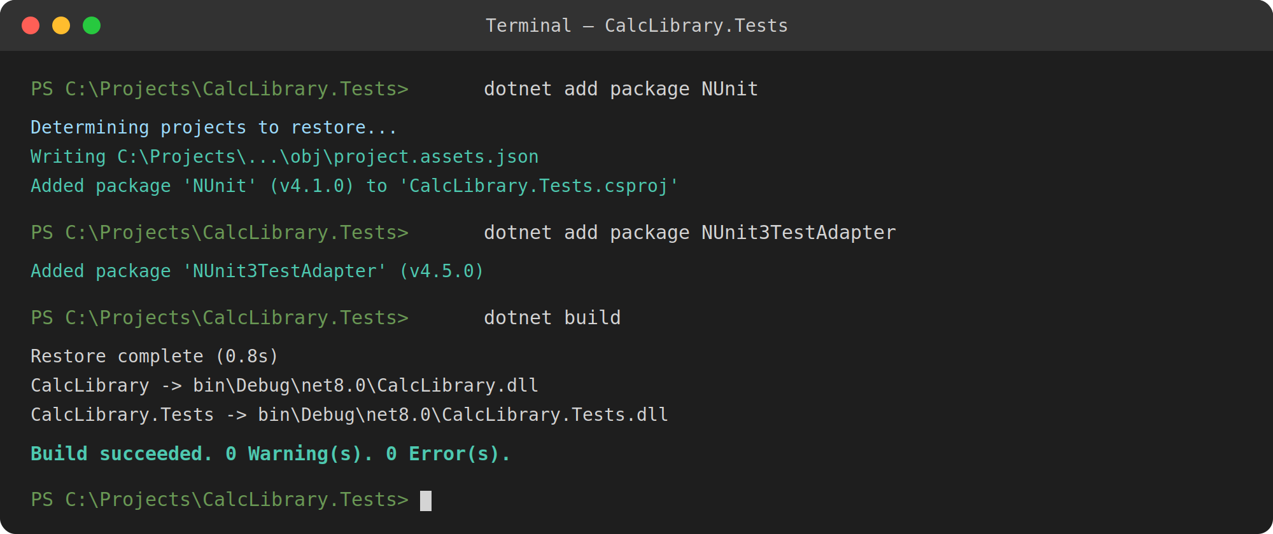
Figure 7: Installing the NUnit packages and confirming the build succeeds.

Step 2 — Write the Class You’re Testing
namespace CalcLibrary
{
public class Calculator
{
public int Add(int a, int b)
{
return a + b;
}
}
}

Step 3 — Write Your First Test
[TestFixture] marks the class as a container of tests. [SetUp] runs before every test method, typically to create a fresh object so tests don’t interfere with each other. [TearDown] runs after each test to clean up.
using NUnit.Framework; using CalcLibrary;

namespace CalcLibrary.Tests
{
[TestFixture]
public class CalculatorTests
{
private Calculator calculator;
[SetUp]
public void Setup()
{
calculator = new Calculator();
}
[TearDown]
public void Cleanup()
{
calculator = null;
}
[Test]
public void Add_TwoPositiveNumbers_ReturnsSum()
{
int actual = calculator.Add(2, 3);
Assert.That(actual, Is.EqualTo(5));
}
}
}
Assert.That compares the value produced against the expected value, and NUnit reports pass or fail based on that comparison.

Step 4 — Cover More Cases with TestCase
[TestCase] feeds multiple sets of inputs into the same test method, including a negative-number case to check behavior outside the happy path.
[TestCase(2, 3, 5)]
[TestCase(10, 20, 30)]
[TestCase(15, 5, 20)]
[TestCase(-5, 5, 0)]
public void Add_ShouldReturnExpectedResult(int a, int b, int expected)
{
int actual = calculator.Add(a, b);
Assert.That(actual, Is.EqualTo(expected));
}
NUnit runs this method once per TestCase line, treating each as its own independent test with its own pass/fail result.

Step 5 — Run the Tests
Run the suite from the command line with dotnet test, or from the Test Explorer panel in Visual Studio.

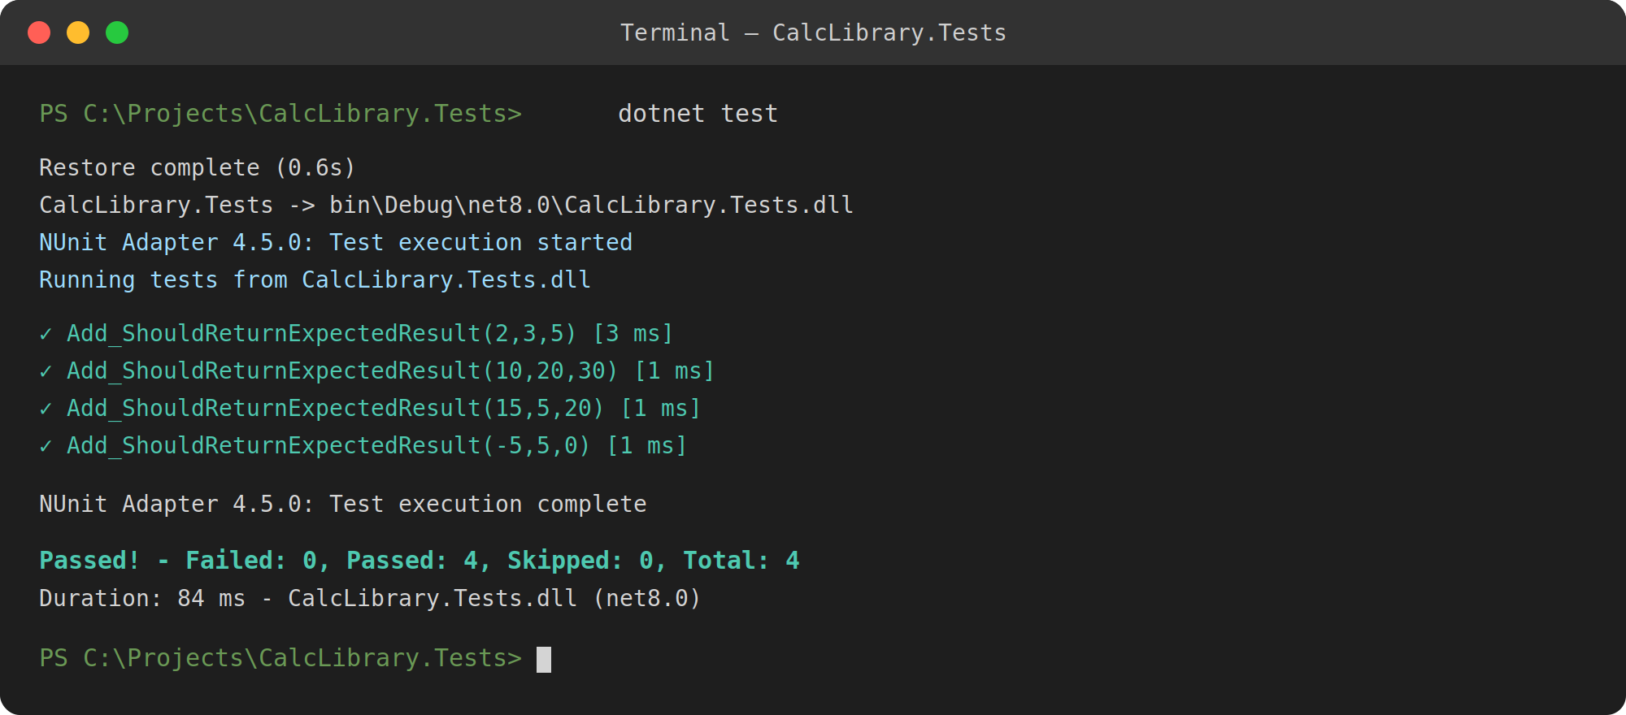
Figure 8: Command-line output after running dotnet test — all four cases pass.
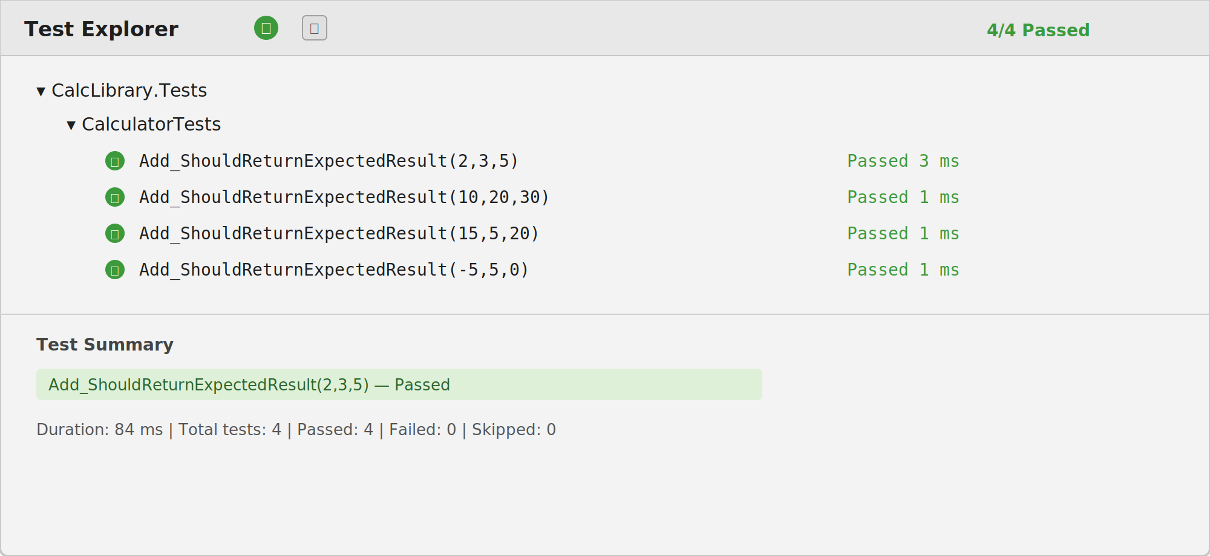
Figure 9: The same four test cases as they appear in Visual Studio’s Test Explorer.

If the Add method is deliberately broken (e.g., changing the return statement to a - b), rerun-ning the tests shows exactly which cases fail, with the expected and actual values for each.

Where to Go from Here
This pattern — SetUp, write the method, write a test, add TestCase variations, run — scales to real applications with many classes and hundreds of tests. Next steps include testing the other arithmetic operations, handling exceptions (e.g., dividing by zero), and introducing mocking for classes that depend on databases or external services.

Hands-On 2: Parameterized Tests, Void Methods, and Ex-ception Handling
This section covers methods that return nothing, methods meant to throw on bad input, and why private methods generally aren’t tested directly — using the same Calculator and a new MathLibrary class.
Download the starter project from the shared link for this module and open it in Visual Studio; it already contains the CalcLibrary and MathLibrary classes referenced below.

Assertions
NUnit also supports Assert.AreEqual(expected, actual), the older, more traditional style (arguments in the opposite order from Assert.That), used for most of this section. Assert.Fail is different: it doesn’t compare anything, it immediately fails the test with a message you provide
— useful when a line of code should never be reached.

Why Not Test Private Methods Directly
A private method only exists to support a public method; it has no meaning outside the class. Testing it directly locks in exactly how the class does its internal work, so a harmless refactor (renaming or splitting a helper) breaks tests that were never about behavior. Testing the public method that calls it means a bug in the private method still surfaces, and the test survives internal reshuffling.

Step 1 — Test Subtraction with Multiple TestCases
[TestCase(10, 3, 7)]
[TestCase(5, 5, 0)]
[TestCase(-4, 6, -10)]
public void Subtract_ShouldReturnExpectedResult(int a, int b, int expected)
{
int actual = calculator.Subtract(a, b);
Assert.AreEqual(expected, actual);
}

Step 2 — Test Multiplication with Multiple TestCases
[TestCase(4, 5, 20)]
[TestCase(0, 9, 0)]
[TestCase(-3, 3, -9)]
public void Multiply_ShouldReturnExpectedResult(int a, int b, int expected)
{
int actual = calculator.Multiply(a, b);
Assert.AreEqual(expected, actual);
}

Step 3 — Test Division, Including Division by Zero
Dividing by zero should throw an ArgumentException rather than return a value, so this test checks for the exception itself.

[TestCase(20, 4, 5)]
[TestCase(9, 3, 3)]
public void Divide_ShouldReturnExpectedResult(int a, int b, int expected)
{
int actual = calculator.Divide(a, b);
Assert.AreEqual(expected, actual);
}
[TestCase(10, 0)]
public void Divide_ByZero_ThrowsArgumentException(int a, int b)
{

try
{

}

calculator.Divide(a, b); Assert.Fail("Division by zero");

catch (ArgumentException ex)
{
Assert.IsInstanceOf<ArgumentException>(ex); StringAssert.Contains("divide by zero", ex.Message.ToLower());
}
}
If Divide throws as expected, execution jumps to the catch block, which checks both the excep-tion type and message. If it doesn’t throw, execution falls through to Assert.Fail("Division by zero"), which fails the test with that message.
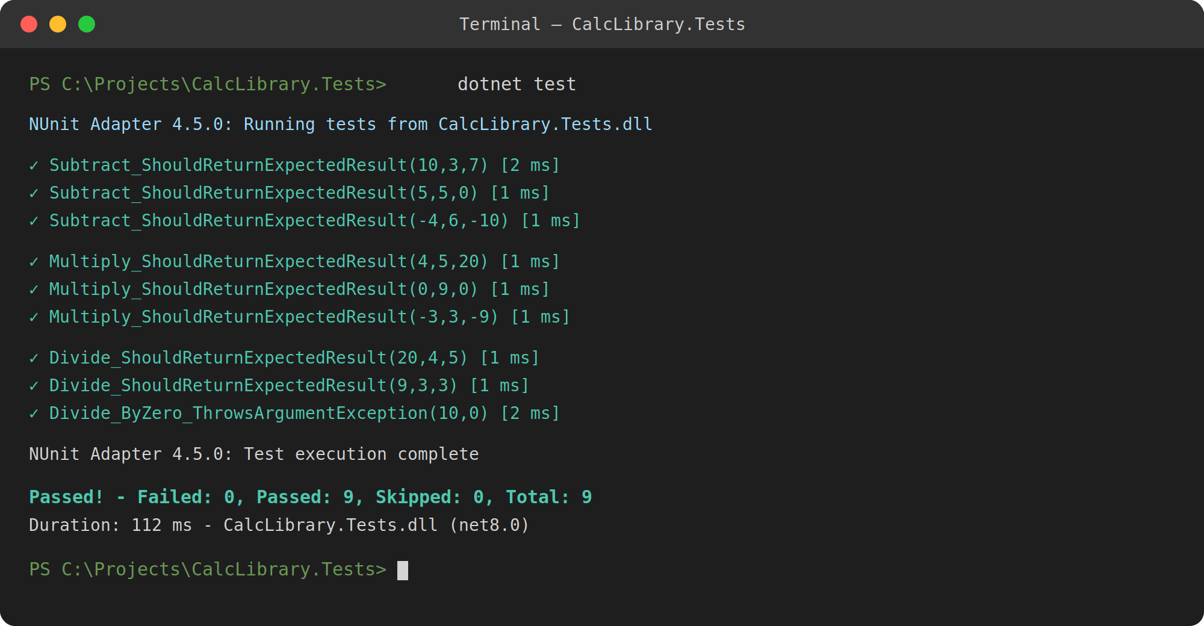
Figure 10: All subtraction, multiplication, and division cases running via dotnet test — the divide-by-zero case passes because the exception was caught and verified correctly.

Step 4 — Test a Void Method
MathLibrary stores the outcome of every operation in an internal result field, exposed via a GetResult property, and has an AllClear() method that resets that field to zero. Since AllClear returns nothing, the test checks the object’s state before and after calling it.
[Test]
public void TestAddAndClear()

{
mathLibrary.Add(10, 5);
Assert.AreEqual(15, mathLibrary.GetResult);
mathLibrary.AllClear();
Assert.AreEqual(0, mathLibrary.GetResult);
}
This is the general pattern for testing a void method: call it, then check some other observable effect — a field, a property, a file that should now exist, a collaborator that should have been called.
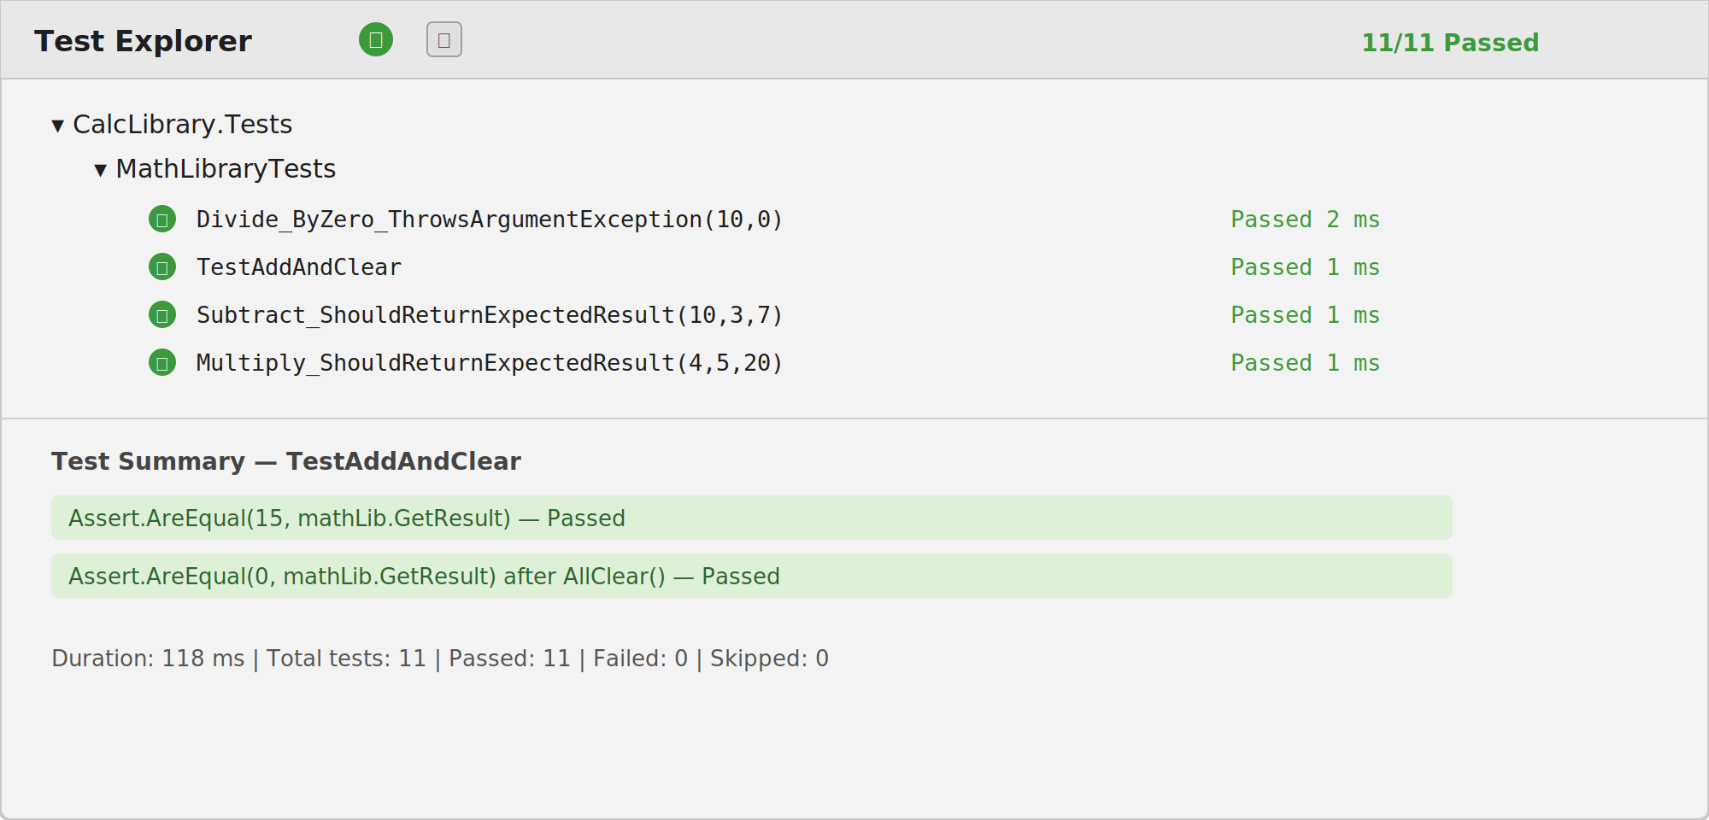
Figure 11: Test Explorer showing the full set of tests, including TestAddAndClear and the division-by-zero case, all passing.

Step 5 — Mocking External Dependencies
Everything tested so far is pure logic — no database, no file system, no network call — which keeps tests fast and reliable. Once a class depends on something like a database connection, testing it for real means a test can fail because the database was slow or unreachable, unrelated to whether the code is correct.
Mocking replaces the real dependency with a fake object under the test’s control. In .NET, the most common library for this is Moq: you configure what the mock returns for a given method call, inject it into the class the same way the real dependency would be injected, and test the class’s logic in isolation.
var mockRepository = new Mock<IDataRepository>(); mockRepository.Setup(repo => repo.GetValue()).Returns(42);
var service = new CalculationService(mockRepository.Object); int result = service.ProcessStoredValue();
Assert.AreEqual(84, result);

Here, IDataRepository is never touched for real — CalculationService just thinks it’s talking to a real data source. This only works if the class was written against an interface in the first place, which is the loose coupling idea from the theory section paying off directly.

Hands-On 3: Testing the UrlHostNameParser Utility
This lab uses an existing utility project: build a test project around ParseHostName, defined on the UrlHostNameParser class inside the UtilLib project.

Naming Conventions
  - Test project name: <ClassLibProject>.Tests — e.g., UtilLib → UtilLib.Tests.
  - Test class name: <SUT>Tests, where SUT stands for System Under Test.
  - Test method name: UnitUnderTest Scenario ExpectedOutcome.
Also follow the single assertion rule: one test, one Assert call. A test with several assertions stacked together tells you something failed, but not which one, without opening a debugger.

Understanding the Method Under Test
ParseHostName takes a URL and returns the host name, stripping a leading www. if present.
public class UrlHostNameParser
{
public string ParseHostName(string url)
{
var uri = new Uri(url); string hostName = uri.Host;
if (hostName.StartsWith("www."))
{
hostName = hostName.Substring(4);
}
return hostName;
}
}
There are two paths through this method: host name starts with www. (prefix stripped), and host name doesn’t (returned as-is). A single test only exercises one path, so at least two test methods are needed to cover both branches.

Step 1 — Create the Test Project
Download the UtilLib starter project and open its solution. Add a new Class Library project named UtilLib.Tests.

Step 2 — Rename the Test Class File
Rename the default class file to UrlHostNameParserTests.cs.

Step 3 — Reference the UtilLib Project
Add a project reference from UtilLib.Tests to UtilLib (Solution Explorer → right-click Dependencies → Add Project Reference).

Step 4 — Add NUnit via NuGet
Add NUnit, NUnit3TestAdapter, and Microsoft.NET.Test.Sdk to the test project.

Step 5 — Write the Test Methods
Two tests, one per execution path, each with a single Assert.That assertion.
using NUnit.Framework; using UtilLib;
namespace UtilLib.Tests
{
[TestFixture]
public class UrlHostNameParserTests
{
private UrlHostNameParser parser;
[SetUp]
public void Setup()
{
parser = new UrlHostNameParser();
}
[Test]
public void ParseHostName_UrlWithWwwPrefix_ReturnsHostNameWithoutWww()
{
string actual = parser.ParseHostName("https://www.example.com");
Assert.That(actual, Is.EqualTo("example.com"));
}
[Test]
public void ParseHostName_UrlWithoutWwwPrefix_ReturnsHostNameUnchanged()
{
string actual = parser.ParseHostName("https://example.com");
Assert.That(actual, Is.EqualTo("example.com"));
}
}
}

Step 6 — Run the Tests
Run with dotnet test or from Visual Studio’s Test Explorer. Both tests should pass, confirm-ing both execution paths behave correctly.
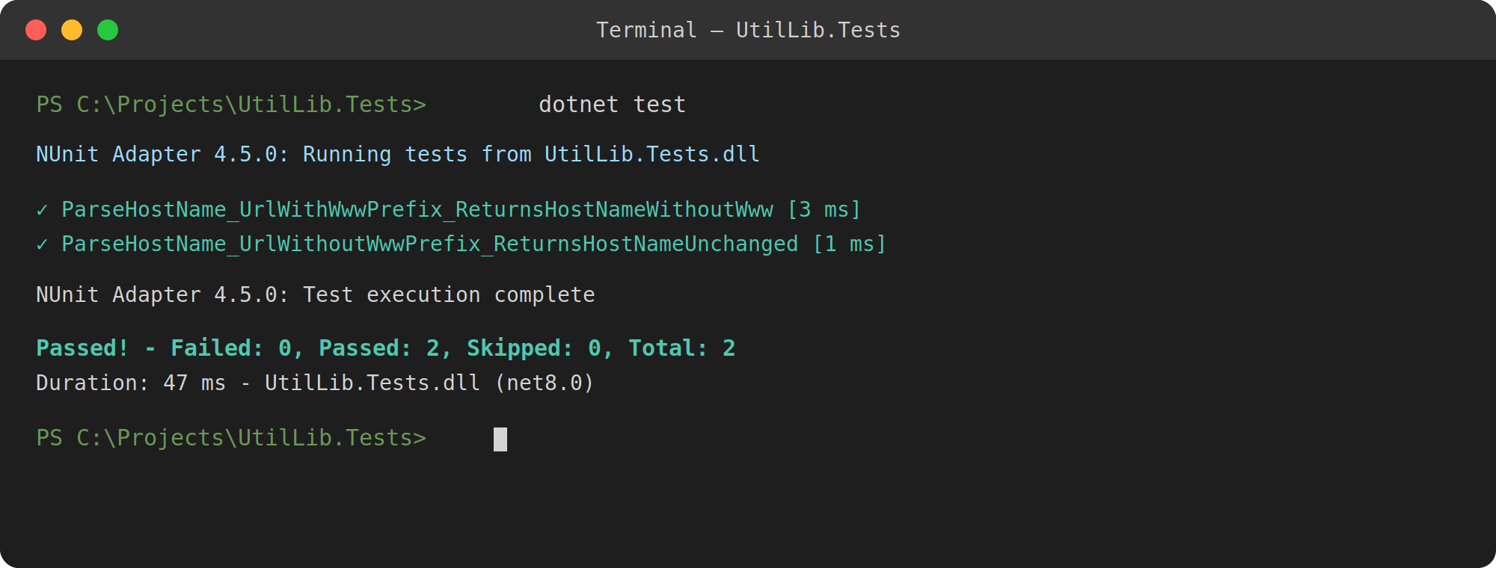
Figure 12: Both ParseHostName tests passing against the unmodified UtilLib source.

Step 7 — Break the Test on Purpose
Comment out the if block in ParseHostName so the www. prefix never gets stripped:
public string ParseHostName(string url)
{
var uri = new Uri(url); string hostName = uri.Host;
// if (hostName.StartsWith("www."))
// {
// hostName = hostName.Substring(4);
// }
return hostName;
}

Step 8 — Rerun the Tests
dotnet test

Step 9 — Observe the Result
The test covering the www. case should now fail, while the other one still passes, since only one of the two paths was broken.
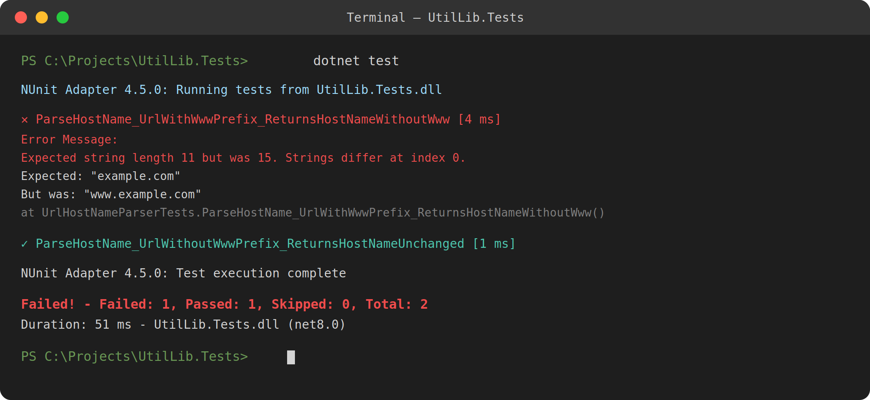
Figure 13: After commenting out the prefix-stripping logic, the www. test fails and reports the exact expected-versus-actual mismatch, while the other test still passes.

Revert the change afterward so the source project is back to working order.

Hands-On 4: Testing the AccountsManagerLib Login Func-tion
This lab’s method has three outcomes: a successful login, a rejected login, and a case that should never execute at all.

Understanding the Method Under Test
AccountsManagerLib exposes a Login method used by the EMS portal. Given a valid user id and password, it returns a welcome message. Given a recognized-but-wrong combination, it returns an error message rather than throwing. If either the user id or password is missing, it throws an ArgumentException rather than attempting to validate.
public class AccountsManager
{
private readonly Dictionary<string, string> validUsers = new Dictionary<string, string>
{
{ "user_11", "secret@user11" },
{ "user_22", "secret@user22" }
};
public string Login(string userId, string password)
{
if (string.IsNullOrEmpty(userId) || string.IsNullOrEmpty(password))
{
throw new ArgumentException("User id and password are required.");
}
if (validUsers.ContainsKey(userId) && validUsers[userId] == password)
{
return $"Welcome {userId}!!!";
}
return "Invalid user id/password";
}
}
That gives three execution paths to cover — at least three test methods, one per outcome — plus a fourth to check that leaving out either credential is treated the same way.

Step 1 — Create the Test Project
Download the AccountsManagerLib starter project and open its solution. Add a new Class Library project named AccountsManagerLib.Tests.

Step 2 — Rename the Test Class File
Rename the default class file to AccountsManagerTests.cs.

Step 3 — Reference the AccountsManagerLib Project
Add a project reference from AccountsManagerLib.Tests to AccountsManagerLib.

Step 4 — Add NUnit via NuGet
Add NUnit, NUnit3TestAdapter, and Microsoft.NET.Test.Sdk to the test project.

Step 5 — Write the Test Methods
The two valid credential pairs are covered with TestCase rather than two separate methods, since they’re the same scenario with different data.
using NUnit.Framework; using AccountsManagerLib;
namespace AccountsManagerLib.Tests
{
[TestFixture]
public class AccountsManagerTests
{
private AccountsManager accountsManager;
[SetUp]
public void Setup()
{
accountsManager = new AccountsManager();
}
[TestCase("user_11", "secret@user11")] [TestCase("user_22", "secret@user22")]
public void Login_ValidCredentials_ReturnsWelcomeMessage(string userId, string password)
{
string actual = accountsManager.Login(userId, password);
Assert.That(actual, Is.EqualTo($"Welcome {userId}!!!"));
}
[Test]
public void Login_InvalidCredentials_ReturnsErrorMessage()
{
string actual = accountsManager.Login("user_11", "wrong_password");
Assert.That(actual, Is.EqualTo("Invalid user id/password"));
}
[Test]
public void Login_MissingUserId_ThrowsArgumentException()
{
Assert.That(() => accountsManager.Login("", "secret@user11"), Throws.TypeOf<ArgumentException>());
}
[Test]
public void Login_MissingPassword_ThrowsArgumentException()
{
Assert.That(() => accountsManager.Login("user_11", ""), Throws.TypeOf<ArgumentException>());
}
}
}
The last two tests use Assert.That paired with Throws.TypeOf<T>() to check that a delegate throws a specific exception type — no manual try/catch needed.

Step 6 — Run the Tests
Run with dotnet test. All five cases — two valid logins, one invalid login, and two missing-credential cases — should pass.
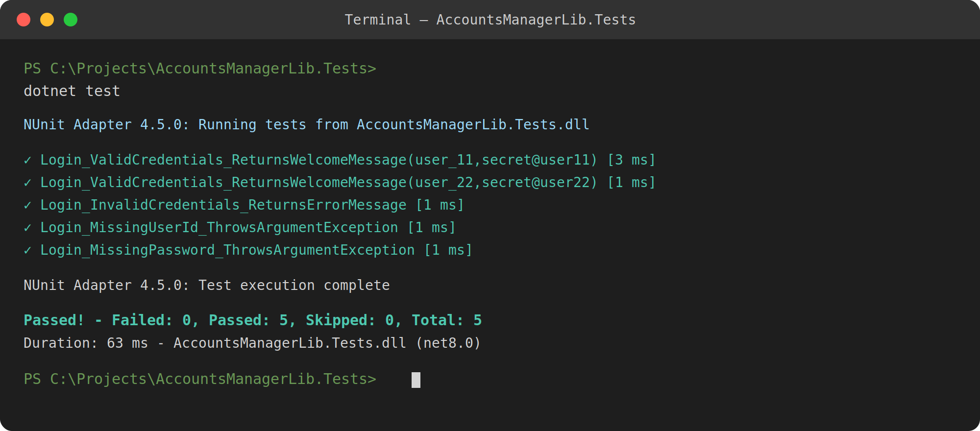
Figure 14: All five Login tests passing against the unmodified AccountsManagerLib source.

Step 7 — Break the Test on Purpose
Remove the credential check entirely so an invalid login is wrongly accepted:
public string Login(string userId, string password)
{
if (string.IsNullOrEmpty(userId) || string.IsNullOrEmpty(password))
{
throw new ArgumentException("User id and password are required.");
}
// Bug: skips the credential check and always welcomes the user. return $"Welcome {userId}!!!";
}

Step 8 — Rerun the Tests
dotnet test

Step 9 — Observe the Result
Login InvalidCredentials ReturnsErrorMessage should now fail, since the broken code wel-comes a user it should have rejected, while every other test still passes.
Revert the change once you’ve confirmed the test suite catches it.

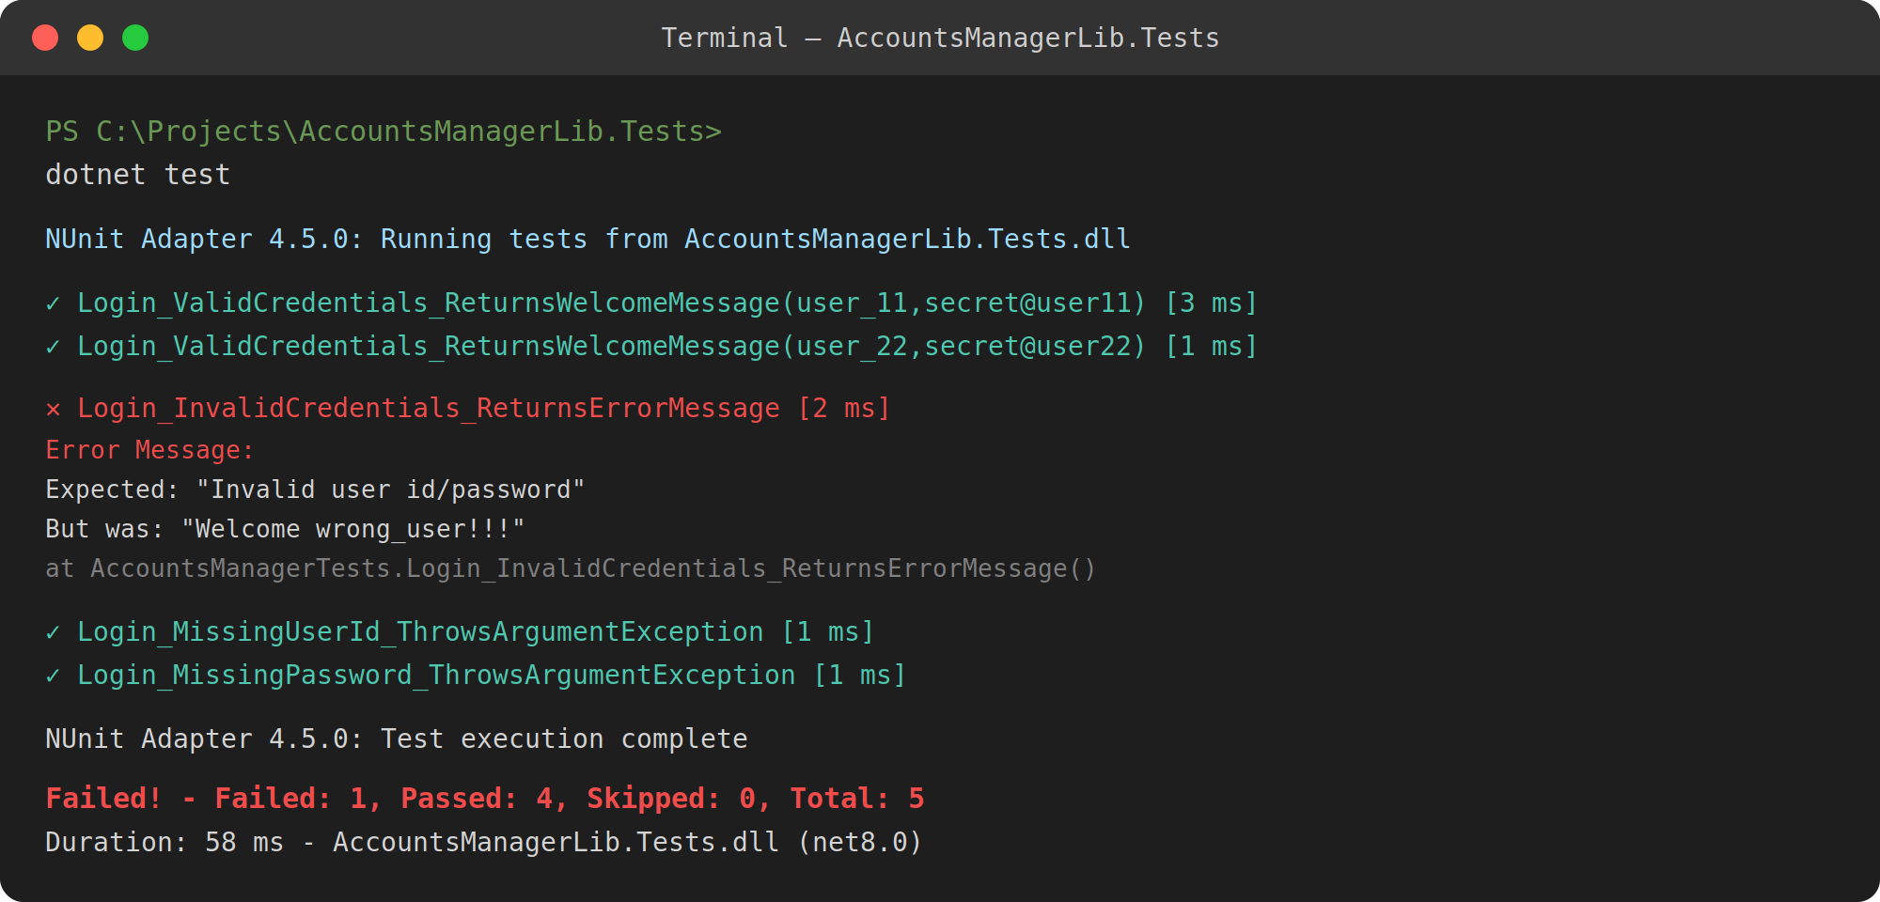
Figure 15: After removing the credential check, the invalid-login test fails and shows exactly what was returned instead of the expected error message.

Hands-On 5: Testing Collections with CollectionAssert
This lab tests a whole collection at once, using NUnit’s dedicated CollectionAssert assertions.

Classic Model vs. Constraint Model
NUnit supports two assertion styles. The Classic Model uses separate static methods for each check, like Assert.AreEqual, Assert.IsTrue, or CollectionAssert.Contains. The Con-
straint Model is built around Assert.That paired with a constraint object — Assert.That(collection, Has.None.Null) reads almost like a sentence. The constraint model is generally preferred since constraints can be combined, but the classic CollectionAssert methods are still common in
existing code, so this lab uses both.

Understanding the Source Project
CollectionsLib exposes an EmployeeRepository with two methods: GetEmployees(), return-ing every employee, and GetEmployeesWhoJoinedInPreviousYears(), filtering to employees who joined before the current year.
public class Employee
{
public int Id { get; set; } public string Name { get; set; } public int JoinYear { get; set; }
public override bool Equals(object obj)
{
if (obj is not Employee other) return false; return this.Id == other.Id;
}
public override int GetHashCode()
{
return Id.GetHashCode();
}
}

public class EmployeeRepository
{
public List<Employee> GetEmployees()
{
return new List<Employee>
{
 |  | new | Employee | { | Id | = | 100, | Name | = | "Asha", | JoinYear | = | 2019 | },
 |  | new | Employee | { | Id | = | 101, | Name | = | "Ravi", | JoinYear | = | 2020 | },
} | }; | new | Employee | { | Id | = | 102, | Name | = | "Meera", | JoinYear | = | 2021 | }
public List<Employee> GetEmployeesWhoJoinedInPreviousYears()
{
return GetEmployees()
.Where(e => e.JoinYear < DateTime.Now.Year)
.ToList();
}
}
The Equals and GetHashCode overrides matter: by default, two Employee objects are only equal if they’re the same object in memory. Overriding equality to compare by Id is what makes it possible to check for duplicates or whether two collections contain the same employees.

Step 1 — Create the Test Project
Download the CollectionsLib starter project and open its solution. Add a new Class Library project named CollectionsLib.Tests.

Step 2 — Rename the Test Class File
Rename the default class file to EmployeeRepositoryTests.cs.

Step 3 — Reference the CollectionsLib Project
Add a project reference from CollectionsLib.Tests to CollectionsLib.

Step 4 — Add NUnit via NuGet
Add NUnit, NUnit3TestAdapter, and Microsoft.NET.Test.Sdk to the test project.

Step 5 — Write the Test Methods
Scenario 1 — No null values in the collection. Written both ways to compare the two styles directly.
[Test]
public void GetEmployees_Always_ReturnsNoNullEmployees_Classic()
{
var employees = repository.GetEmployees();
CollectionAssert.DoesNotContain(employees, null);
}
[Test]
public void GetEmployees_Always_ReturnsNoNullEmployees_Constraint()
{

var employees = repository.GetEmployees();
Assert.That(employees, Has.None.Null);
}

Scenario 2 — Employee 100 exists in the collection.
[Test]
public void GetEmployees_EmployeeId100_Exists()
{
var employees = repository.GetEmployees();
Assert.That(employees, Has.Some.Matches<Employee>(e => e.Id == 100));
}
Scenario 3 — Every employee in the collection is unique. This relies on the Equals/GetHashCode override — without it, AllItemsAreUnique would fall back to reference equality and treat every
object as unique regardless of Id.
[Test]
public void GetEmployees_Always_ReturnsUniqueEmployees()
{
var employees = repository.GetEmployees();
CollectionAssert.AllItemsAreUnique(employees);
}
Scenario 4 — GetEmployees() and GetEmployeesWhoJoinedInPreviousYears() return the same items. Since every employee in the sample data joined before the current year, both methods should return an equivalent set.
[Test]
public void GetEmployeesAndPreviousYearEmployees_Always_ContainSameItems()
{
var allEmployees = repository.GetEmployees();
var previousYearEmployees = repository.GetEmployeesWhoJoinedInPreviousYears();
CollectionAssert.AreEquivalent(allEmployees, previousYearEmployees);
}
AreEquivalent checks that both collections contain the same items regardless of order — AreEqual would also require matching sequence order, which isn’t part of this check.

Step 6 — Run the Tests
dotnet test

All five tests should pass against the unmodified source.

Step 7 — Break the Test on Purpose
Introduce a duplicate id into the sample data:
public List<Employee> GetEmployees()
{
return new List<Employee>
{
new Employee { Id = 100, Name = "Asha", JoinYear = 2019 },

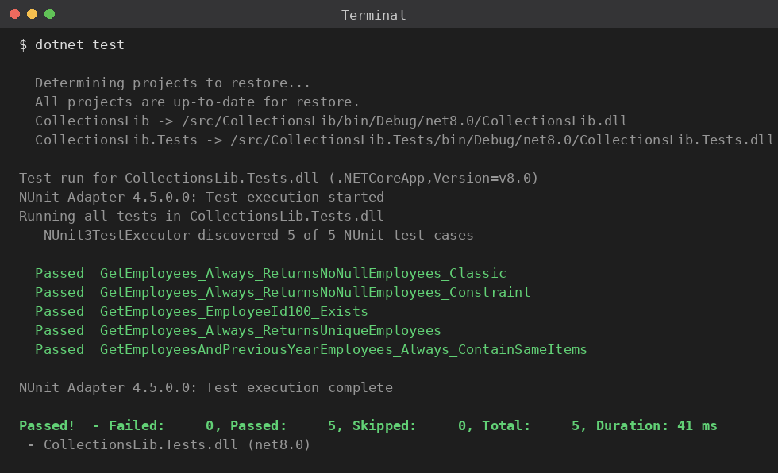
Figure 16: All five collection tests passing, including both the classic and constraint versions of the null check.

new Employee { Id = 101, Name = "Ravi", JoinYear = 2020 },
new Employee { Id = 101, Name = "Meera", JoinYear = 2021 } // duplicate Id
};
}

Step 8 — Rerun the Tests
dotnet test

Step 9 — Observe the Result
GetEmployees Always ReturnsUniqueEmployees should now fail, since two employees share an Id and the overridden Equals correctly identifies them as duplicates. Every other test keeps passing, since none of the other scenarios depend on uniqueness.
Revert the sample data once you’ve confirmed the test suite flags the duplicate correctly.

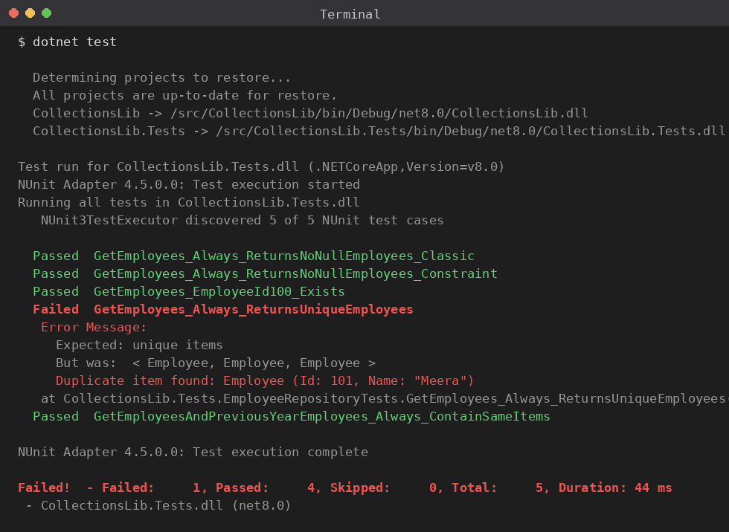
Figure 17: After introducing a duplicate employee Id, CollectionAssert.AllItemsAreUnique catches it immediately and names the duplicate.

